SECTION 1 — Introduction
Title:
Machine Learning Detection of Ransomware Using Static Features
Introduction:
Ransomware is a type of malware that encrypts files and demands payment from the victim. Detecting ransomware quickly is critical in order to protect data, prevent damage, and assist digital forensics investigations.
In this project, I used supervised machine learning models to classify files as Benign or Malware (Ransomware) using the Ransomware Dataset 2024. The dataset contains static features extracted from executable files, such as header fields, PE structure information, and behavioral counters.
In this report, I describe how I prepared the data, trained two different models (Logistic Regression and Random Forest), and evaluated their performance for ransomware detection.
Background concepts and terminology were guided by course textbooks, including Machine Learning: A First Course for Engineers and Scientists and Murphy’s Probabilistic Machine Learning.
The goals of this project were to:
- Load and preprocess the dataset
- Train different machine learning models
- Compare performance
- Identify strengths and weaknesses of each approach
SECTION 2 — Dataset and Preprocessing
The dataset used in this project is the Ransomware Dataset 2024, which contains static features extracted from Windows PE (Portable Executable) files.
Each file is labeled as:
- Benign (normal software), or
- Malware (Ransomware)
The dataset includes:
- PE header values
- section metadata
- registry activity counters
- API and DLL counts
- network-related statistics
These values describe file behavior without needing to run the malware.

Data Cleaning
Before training, I removed:
- non-numeric fields (file names, hashes)
- duplicate records
- unused identifiers
Then I converted any hexadecimal values (such as 0x1000) into integers so the models could read them.

Class Balance
The dataset was balanced:
- 10,876 benign samples
- 10,876 ransomware samples
Balanced classes help prevent model bias.

Train / Test Split
The dataset was split:
- 75% training data
- 25% testing data
The split was stratified, meaning both sets kept the same malware/benign ratio.

Why preprocessing matters
Effective preprocessing ensures the model receives clean, meaningful information and improves overall accuracy and reliability.
- Avoid bias in training
- Handle differences in feature scale
- Ensure only meaningful information is used
- Improve training efficiency
- Improve prediction accuracy

SECTION 3 — Model Training

Overview
Two machine-learning models were trained:
- Logistic Regression
- Random Forest Classifier
Both models were trained using the cleaned dataset and evaluated on the test set.

Logistic Regression
Logistic Regression is a simple baseline classifier used to predict whether a file is Benign or Malware.
Logistic regression is commonly introduced as a baseline classification method in standard machine learning texts (Alpaydin, 2020).
To prevent convergence warnings, I increased the optimization limit:

max_iter = 500
This model is:
- fast
- easy to interpret
- good as a baseline comparison
However, it may struggle with complex non-linear patterns.

Random Forest
Random Forest builds many decision trees and combines their results.
Model parameters used:
n_estimators = 300
random_state = 42
n_jobs = -1
Advantages:
- handles complex patterns
- resistant to noise
- works well with many features
- provides feature-importance ranking
Because ransomware has complicated behavior patterns, Random Forest was expected to perform better.

SECTION 4 — Results

4.1 Model Accuracy
Both models were evaluated using the test dataset.
The Random Forest model achieved the highest accuracy:
- Logistic Regression: 0.74 (74%)
- Random Forest: 0.95 (95%)
Random Forest clearly performs better for ransomware detection.
The overall accuracy is shown in Figure 2.
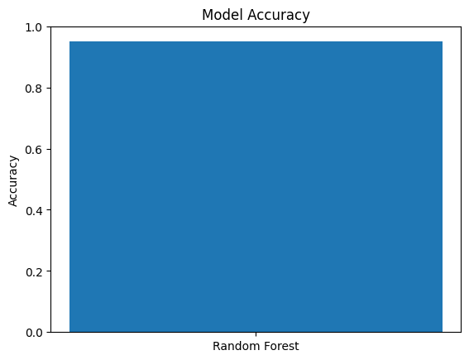

Figure 2. Overall accuracy of the Random Forest ransomware classifier.

4.2 Model Comparison (Expanded Experiments)
To expand the project beyond the original two-model baseline, additional machine learning classifiers were added and evaluated. In total, four classic machine learning models were tested using static PE-based features [1]:
Logistic Regression (baseline)
- Random Forest
- SVM (RBF kernel)
- KNN (k=5)
Each model was evaluated using Accuracy, Precision, Recall, F1-score, and ROC-AUC [1]. The results show that SVM (RBF kernel) achieved the strongest overall performance, with the highest Accuracy and AUC, indicating strong separation between benign files and ransomware samples using static features. Random Forest and KNN also performed well and produced high ROC-AUC values, while Logistic Regression remained useful as a simple interpretable baseline.
Summary: The expanded experiments confirm that classic machine learning models—especially SVM and Random Forest—can provide strong ransomware detection performance using static features alone. All models and evaluation metrics were implemented using scikit-learn [4].

Table 1. Model Performance Comparison (Expanded Experiments)
Model | Accuracy | Precision | Recall | F1-score | ROC-AUC
SVM (RBF kernel) | 0.9400 | 0.9466 | 0.9185 | 0.9323 | 0.9738
Random Forest | 0.9100 | 0.9154 | 0.8815 | 0.8981 | 0.9570
KNN (k=5) | 0.9067 | 0.9213 | 0.8667 | 0.8931 | 0.9606
Logistic Regression | 0.8200 | 0.8092 | 0.7852 | 0.7970 | 0.8934
Note: Higher ROC-AUC indicates better overall separation between benign and ransomware classes across classification thresholds.

4.3 Confusion Matrix
To better understand the model performance, a confusion matrix was generated.
This matrix shows:
- True Positives (correctly identified ransomware)
- True Negatives (correctly identified benign files)
- False Positives (benign flagged incorrectly)
- False Negatives (missed ransomware)
For the Random Forest model:
[[2559 160]
[ 104 2615]]

This means:
- 2,559 benign files were correctly classified
- 2,615 ransomware samples were correctly identified
- 160 benign samples were misclassified as ransomware
- 104 ransomware samples were not detected
The confusion matrix is shown in Figure 1.
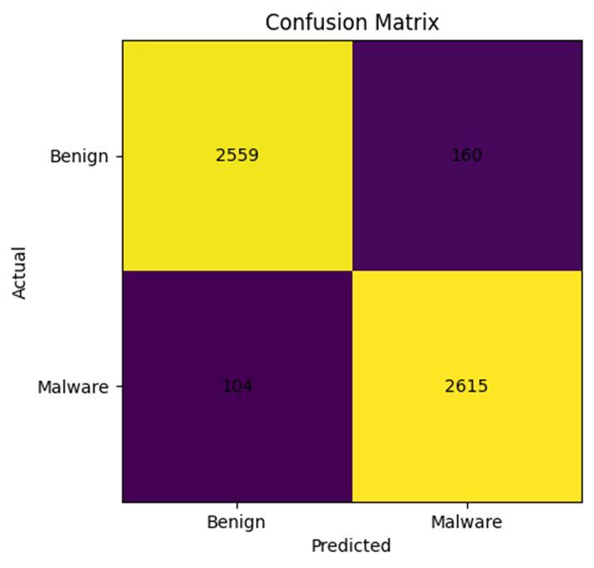

Figure 1. Confusion matrix showing correct detections and misclassifications.

4.4 ROC Curves and AUC Results
To further evaluate classifier performance beyond accuracy, ROC curves were generated for each model along with the Area Under the Curve (AUC) metric. ROC curves show the trade-off between True Positive Rate (Recall) and False Positive Rate at different classification thresholds, while AUC summarizes the overall ability of a model to distinguish between benign and ransomware samples [1].
Across the expanded experiments, SVM (RBF kernel) produced the strongest ROC performance with the highest AUC (~0.9738), indicating excellent separability between benign and ransomware classes. Random Forest, KNN, and SVM all produced high AUC values (≈0.95–0.97), suggesting strong classification performance even when thresholds vary. Logistic Regression produced a lower AUC (~0.8934) but remained a useful baseline model due to its simplicity and interpretability. ROC-AUC provides a threshold-independent measure of class separability [1].
Figures 4-7 show the ROC curves generated for Logistic Regression, Random Forest, SVM (RBF kernel), and KNN (k=5) [4].

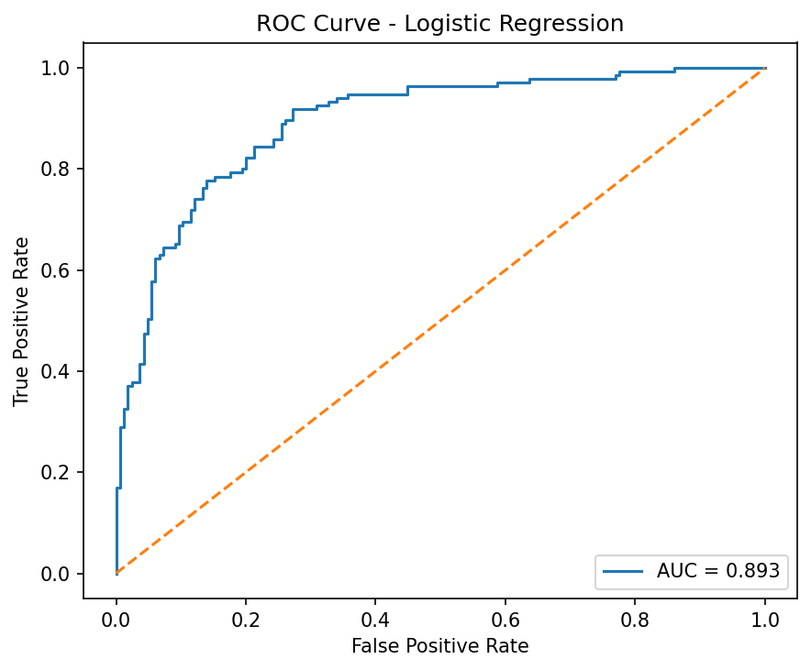
Figure 4. ROC Curve — Logistic Regression

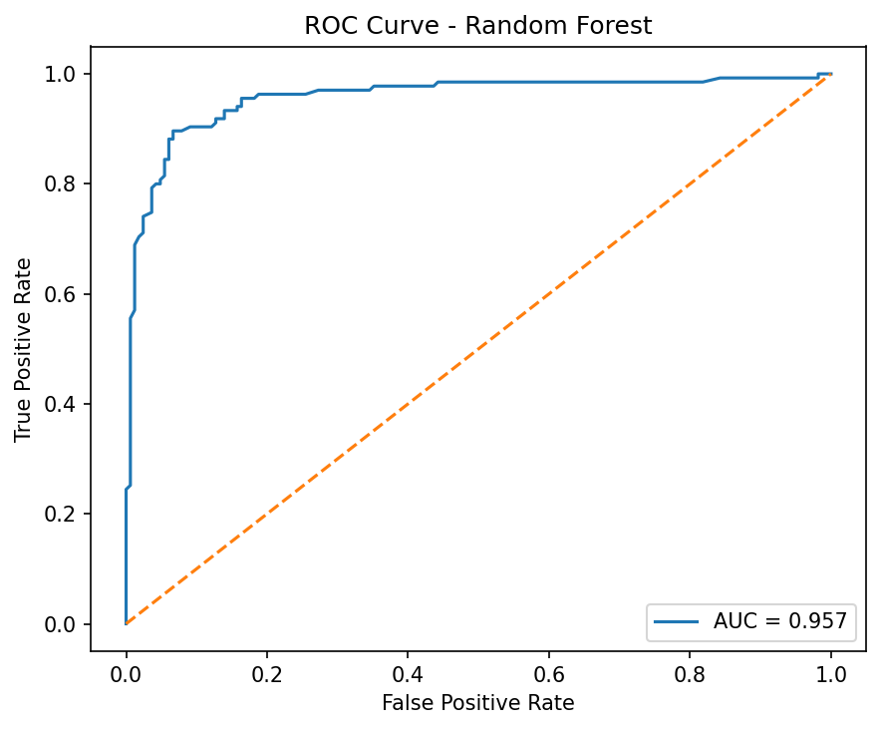
Figure 5. ROC Curve — Random Forest

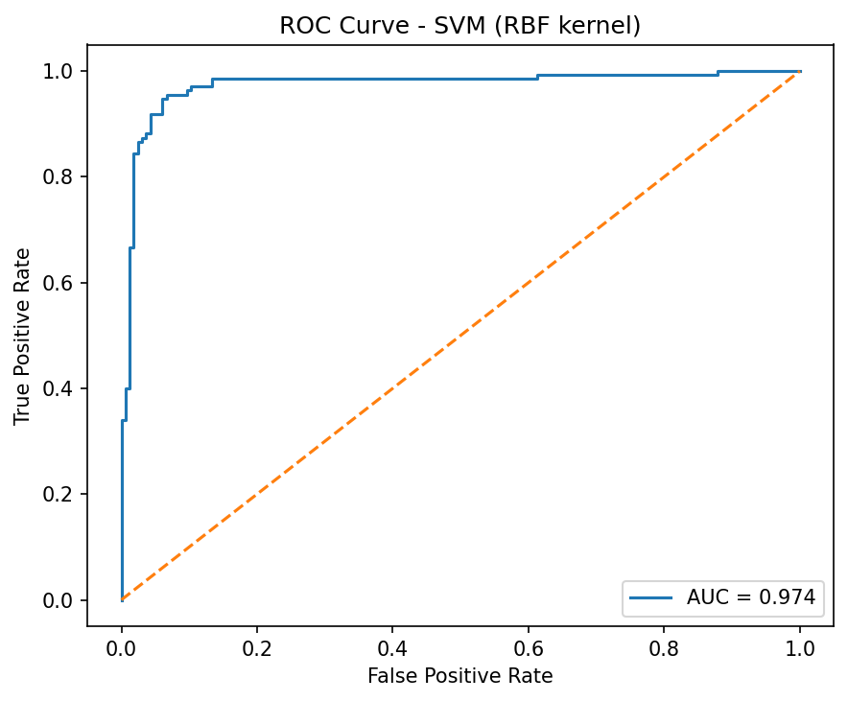
Figure 6. ROC Curve — SVM (RBF kernel)
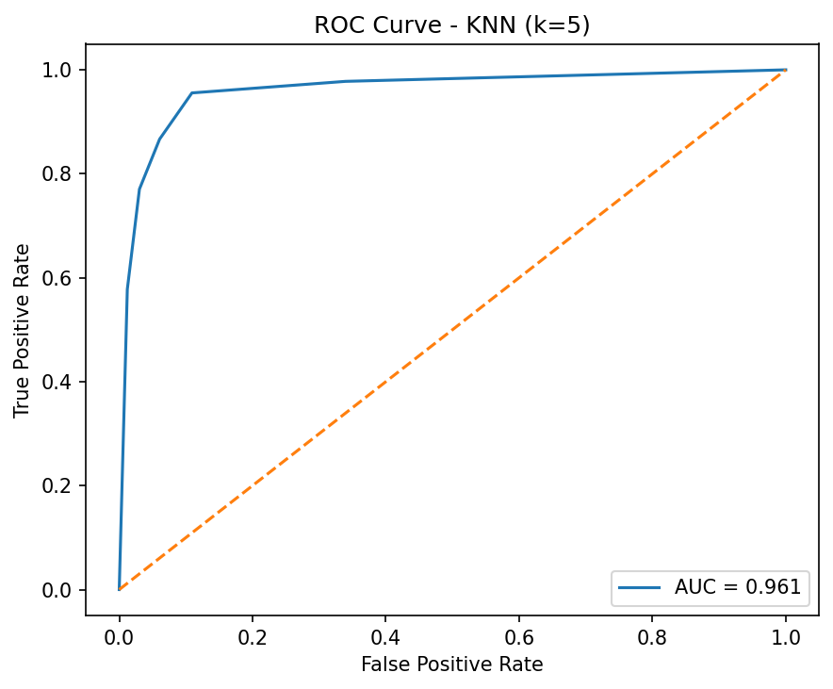

Figure 7. ROC Curve — KNN (k=5)
4.5 Cross-Dataset Generalization (EMBER 2018 Dataset)
To examine cross-dataset generalization, the model training pipeline was applied to an external dataset beyond the original static ransomware dataset. Specifically, a balanced subset was extracted from the EMBER 2018 dataset (Dataset B), containing 10,000 samples (5,000 benign and 5,000 malware) and 2,381 static PE-based features (F1–F2381). The same four classifiers—Logistic Regression, Random Forest, SVM (RBF kernel), and KNN—were trained and evaluated using Accuracy, Precision, Recall, F1-score, and ROC-AUC. Results show consistently strong performance across models, indicating that the approach generalizes well to a different dataset and feature representation. Random Forest achieved the best overall performance with 94.40% accuracy and ROC-AUC of 0.9863, while SVM (RBF) also produced strong performance with 92.45% accuracy and ROC-AUC of 0.9778. Logistic Regression remained an effective baseline, and KNN produced competitive results. Overall, the EMBER evaluation provides evidence that classic ML classifiers can maintain high detection performance beyond a single dataset, supporting feasibility for broader malware detection settings.
Table 2. Cross-Dataset Results on EMBER 2018 (Balanced 10k Subset)
Model | Accuracy | Precision | Recall | F1-score
Random Forest | 0.9440 | 0.9577 | 0.9290 | 0.9431
SVM (RBF kernel) | 0.9245 | 0.9629 | 0.8830 | 0.9212
Logistic Regression | 0.9030 | 0.8928 | 0.9160 | 0.9042
KNN (k=5) | 0.8915 | 0.8857 | 0.8990 | 0.8923

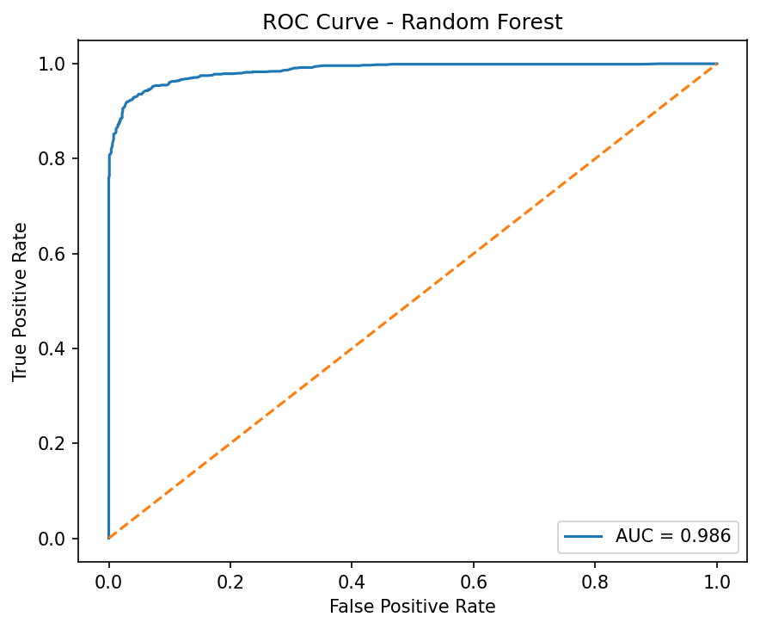

Figure 12. ROC Curve — Random Forest on EMBER 2018 dataset (balanced 10k subset).
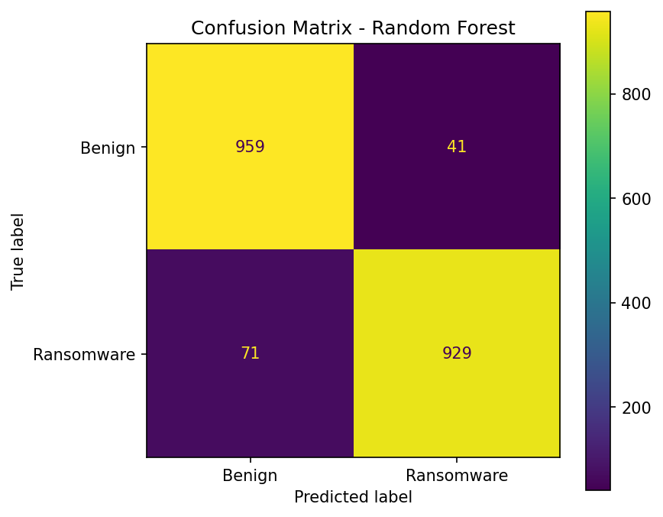

Figure 13. Confusion Matrix — Random Forest on EMBER 2018 dataset (balanced 10k subset).

Figures 12–13 illustrate Random Forest performance on EMBER, confirming strong threshold-independent separability and high classification accuracy on Dataset B.

4.6 Feature Importance (Optional but Powerful)
Random Forest allows us to see which features contributed the most to the classification.
Some of the highest-ranked features were:
- registry_total
- registry_read
- total_processes
- network_dns
- EntryPoint
This suggests that registry activity and process behavior are strong indicators of ransomware.
The feature-importance chart is shown in Figure 3.

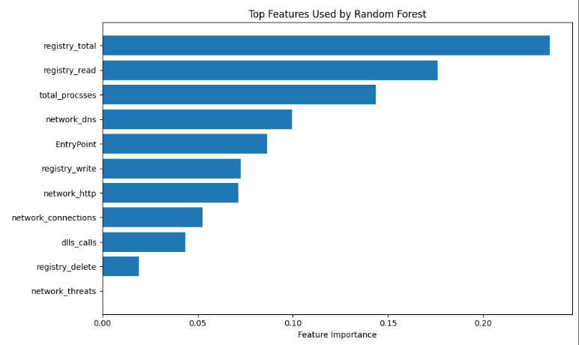

Figure 3. Feature importance results showing the most influential static features.

These features show which characteristics most influenced whether a file was classified as ransomware or benign. Registry activity, process counts, and network behavior were among the most important.

4.7 Interpretation
Overall, the results show:
- Random Forest significantly outperforms Logistic Regression
- The model detects ransomware with high accuracy
- Most misclassifications occur between closely similar files
- Static features alone can still provide strong predictive power

These findings provide useful insight into how static machine learning models behave when detecting ransomware, and they lead directly into the discussion of strengths and limitations in the next section.

SECTION 5 — Discussion

5.1 Strengths of the Approach
The expanded experiments demonstrate that ransomware detection using static feature-based machine learning can be modeled effectively using classic classifiers. Across the evaluated models (Logistic Regression, Random Forest, SVM with RBF kernel, and KNN), the results show consistently strong performance. In particular, SVM (RBF kernel) achieved the best overall results, producing the highest accuracy and ROC-AUC, which indicates strong separation between benign software and ransomware samples. These evaluations were performed using scikit-learn [4].
These findings suggest that non-linear decision boundaries (such as SVM with an RBF kernel) are especially effective when classifying ransomware using static indicators [1]. Random Forest also performed well and provides an important advantage through feature importance analysis, improving interpretability by identifying which static features contribute most to classification [5]. Overall, the results support the value of machine learning for early ransomware detection and confirm that well-engineered static indicators can be useful for quickly identifying suspicious software.

5.2 Limitations
Although the models performed well, there are several important limitations. First, this approach relies only on static features, meaning performance can degrade against ransomware families that use packing, obfuscation, or encryption to hide meaningful indicators. In such cases, static detection may fail or produce weaker confidence.
Second, the dataset used in the experiments is labeled and relatively balanced, while real-world environments are typically highly imbalanced (benign software greatly outnumbers ransomware). As a result, accuracy values may appear high in testing but may decrease when the model is deployed in operational settings.
Finally, false negatives remain a major concern. A missed ransomware detection could allow an attack to execute, encrypt files, and spread across systems. For these reasons, results from academic datasets should be validated further using real-world and more diverse samples before being considered for deployment.

5.3 Future Work
Several extensions could strengthen this approach and improve real-world reliability:
- Include dynamic behavior features, such as file activity patterns, process behavior, and network connections during execution.
- Experiment with additional classifiers, such as Gradient Boosting, XGBoost, or deep learning-based methods.
- Evaluate generalization using newer datasets (different ransomware families, different years, and unseen malware samples).
- Apply threshold tuning and decision calibration to reduce false negatives and control risk in deployment scenarios.
- Perform hyperparameter tuning (e.g., SVM parameters and KNN neighborhood selection) to further optimize model performance.
Exploring these improvements may lead to more robust and scalable ransomware detection systems capable of operating effectively in real-world environments.

5.4 Practical Implications (Security Perspective)
The expanded results suggest that static feature-based ML models can serve as an effective early warning layer for ransomware detection. Because static features can be extracted without executing the file, this approach is suitable for fast triage in environments such as endpoint protection, email attachment scanning, and incident response pipelines.
Models such as SVM (RBF kernel) and Random Forest demonstrated strong detection capability, indicating that ransomware often leaves detectable static patterns even before execution. From a security operations (SOC) standpoint, this method can help prioritize alerts and reduce analyst workload by automatically flagging suspicious samples for deeper inspection.
However, these ML models should not be viewed as a complete defense by themselves. Instead, the most practical use is as a risk scoring component that complements traditional controls such as antivirus signatures, sandbox detonation, endpoint telemetry, and behavioral monitoring. When combined in a layered security design, static ML detection can improve response speed and reduce the window of exposure.

5.5 Deployment Considerations and Recommendations
To improve reliability in real environments, several deployment-related considerations must be addressed. First, classification thresholds should be tuned depending on security goals. For ransomware defense, reducing false negatives is often more important than maximizing overall accuracy, because a missed detection can result in encryption and rapid spread. Threshold tuning based on ROC/AUC analysis provides a structured way to select operating points that balance false positives with detection strength [1].
Second, model evaluation should extend beyond balanced academic datasets. Real-world malware detection is highly imbalanced, with benign programs greatly outnumbering ransomware samples. Future evaluations should include imbalanced test settings and metrics such as precision-recall analysis to better represent operational performance.
Finally, continuous updating is essential. Ransomware evolves quickly, and static indicators may shift over time. A practical recommendation is to periodically retrain models using updated datasets and validate performance on newer ransomware families. In production settings, a hybrid approach is recommended: static ML screening for early detection, followed by dynamic analysis and security telemetry correlation for confirmation.
Overall, these steps support more realistic deployment and increase the likelihood that static feature-based ML models can contribute meaningfully to modern ransomware defense.

5.6 Threats to Validity
Although the experimental results are strong, there are several threats to validity that could affect interpretation. First, the dataset used may not fully represent real-world ransomware diversity, including newer variants, packing techniques, or evasion methods. If certain ransomware families are overrepresented, model performance may appear stronger than it would in a broader deployment setting.
Second, model performance may vary depending on how the dataset was split into training and testing samples. A different split or different random seed could produce slightly different results. Cross-validation and repeated trials would reduce this risk and provide more stable performance estimates.
Finally, static features alone provide an incomplete representation of ransomware behavior. Some malicious behavior only becomes visible at runtime, meaning static detection may miss stealthy samples. For these reasons, the findings should be interpreted as evidence that static ML detection is promising, but not sufficient as a standalone defense without additional validation and dynamic analysis support.

Section 6 — Explainability
Explainability Analysis
To enhance model transparency and support instructor recommendations, explainability was applied to identify which static features contributed most to ransomware detection. For the Random Forest model, feature importance scores were extracted and ranked to highlight the strongest predictors. For Logistic Regression, coefficient weights were analyzed to determine which features most strongly increased or decreased the likelihood of ransomware classification. This analysis helps validate that the model decisions rely on meaningful indicators rather than noise and improves trust for practical security applications. This improves transparency by showing which signals drive classification decisions and supports trust in ML-based detection [1].

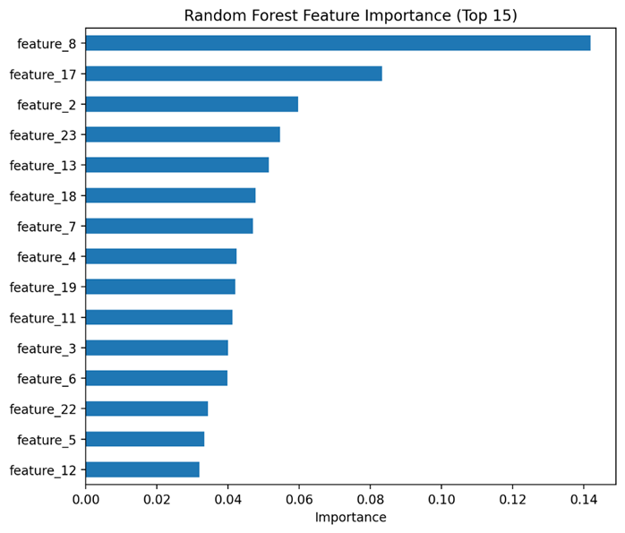

Figure 8. Random Forest Feature Importance (Top 15 Features).

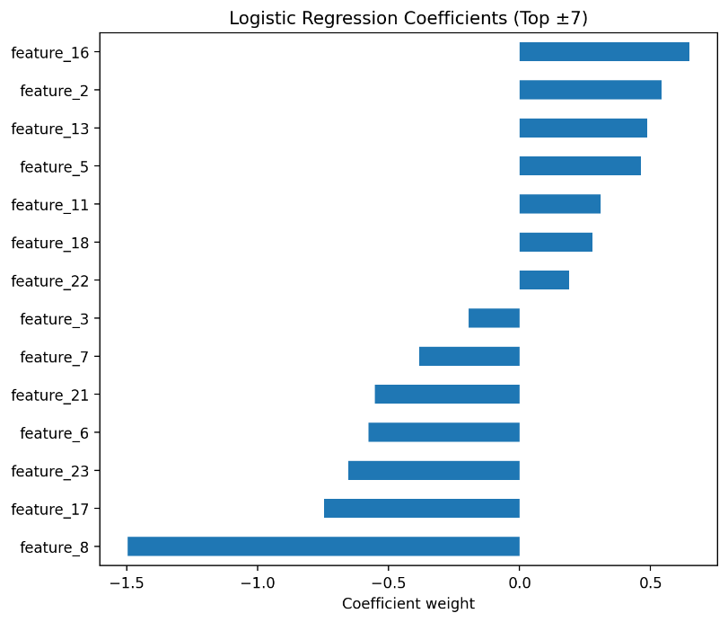

Figure 9. Logistic Regression Coefficients (Top Positive and Negative Features).

Interpretation:
The Random Forest importance ranking highlights the most influential static features used for classification. Logistic Regression coefficient weights further show directional influence, where positive weights increase the probability of ransomware classification while negative weights indicate stronger association with benign behavior.

SECTION 6.1 — Future Work

Two additional extensions are recommended to strengthen the real-world applicability of this ransomware detection approach. First, cross-dataset generalization should be evaluated by training the classifier on one dataset and testing it on a different dataset to quantify robustness under distribution shift. Second, hybrid feature fusion can be explored by combining static file features with dynamic behavioral indicators (e.g., Sysmon/Process activity logs) and comparing performance against static-only and dynamic-only models. These steps would improve model reliability and provide stronger evidence of generalization beyond a single dataset.

SECTION 7 — Conclusion
This project demonstrated that machine learning can be an effective tool for detecting ransomware using static feature-based indicators. Multiple classifiers were evaluated, including Logistic Regression, Random Forest, SVM (RBF kernel), and K-Nearest Neighbors (KNN), to determine how well static indicators can distinguish benign software from ransomware.
Across the expanded experiments, SVM (RBF kernel) achieved the strongest overall performance, producing the highest accuracy and ROC-AUC, indicating excellent class separability. Random Forest and KNN also performed strongly, while Logistic Regression remained useful as a simple and interpretable baseline model. In addition to standard metrics (accuracy, precision, recall, and F1-score), ROC curves were used to evaluate model performance across classification thresholds, providing a deeper assessment of detection quality beyond raw accuracy.
Although the results are promising, static analysis alone is not sufficient for complete protection. Advanced ransomware can hide or obfuscate static indicators through packing or encryption, and real-world environments are often highly imbalanced and noisier than academic datasets. For practical ransomware defense, machine learning solutions should be combined with traditional security controls and dynamic behavior-based analysis to reduce false negatives and improve resilience.
Overall, this work provides evidence that classic machine learning models—especially SVM and Random Forest—can meaningfully enhance ransomware detection using static features, and it offers a foundation for future improvements such as dynamic feature collection, threshold tuning, and evaluation on broader real-world ransomware datasets. Future work will also evaluate cross-dataset generalization and hybrid static–dynamic feature fusion to further improve robustness and real-world applicability.

SECTION 8 — References
- E. Alpaydin, Machine Learning: A First Course for Engineers and Scientists, Cambridge University Press, 2020.
- A. Gut, Introduction to Probability for Computing, Springer, 2013.
- K. P. Murphy, Probabilistic Machine Learning: An Introduction, MIT Press, 2022.
- F. Pedregosa et al., “Scikit-learn: Machine Learning in Python,” Journal of Machine Learning Research, vol. 12, pp. 2825–2830, 2011.
- C. Molnar, Interpretable Machine Learning: A Guide for Making Black Box Models Explainable, 2nd ed., 2022.
- H. Anderson and P. Roth, “EMBER: An Open Dataset for Training Static PE Malware Machine Learning Models,” 2018.

